

(temporary logo)

Software Development Project

Valentin Bonnet | Pier-Luc Gagnon | Etienne Perot

COMP 361 - In-house project
McGill University
Montreal, Canada

Monday November 1st, 2010

Table of contents
Project Overview  - Team description  - Client description  - Project description | 1
Game Overview | 2
Project Specifications | 3
System Diagram | 4
Engine Interactions | 5
Engineering Methods | 6
Timeline | 7
Formal Phase Breakdown | 8
Milestones and Deliverables | 10
Gantt Diagram | 11
Modules | 12
Resource Requirements | 13
Risk and Cost Estimations | 14

Project everVoid

- Team:
  - Bonnet, Valentin - valentin.bonnet@mail.mcgill.ca
  - Gagnon, Pier-Luc - pier-luc.gagnon@mail.mcgill.ca
  - Perot, Etienne - etienne.perot@mail.mcgill.ca
- Contact:
  - Trac: http://evervoid.biringa.com/trac
  - Subversion repository: http://evervoid.biringa.com/svn
  - IRC channel: irc://irc.freenode.net/everVoid (#everVoid on freenode)
  - Guest access: guest / comp361evervoid - (where relevant)
- Stream: In-house, game project
- Clients:
  - Joseph Vybihal - jvybihal@cs.mcgill.ca
  - Jörg Kienzle - joerg.kienzle@mcgill.ca

everVoid is a video game set in space in which players vie for galaxy domination. The game will be implemented in Java, mixing both 3D and 2D graphics. Game play revolves around planets, which yield income and allow players to advance through research “ages”. When a player no longer controls a planet, he is eliminated. Players fight over the control of solar systems, each of which contains a “random” number of planets. Spaceships of various types can be built in order to harass enemy planets, protect friendly ships, or bolster your economy. The economy is based on money, metal and gas. Metal is abundant on asteroids and is used primarily for building ships and buildings. Gas is found on gas planets (much rarer) and is used in research. Terran planets provide a small supply of both metal and gas as well as increasing population, which is needed to build ships. A more detailed explanation of game rules is provided lower in the document.
Game Overview

The game will have the following attributes:
- Basic turn-based play style
  - All turns handed in and then worked on
- The objective of the game is to annihilate the enemy(ies)
  - Alternative win, through “wonder”-like structure
- Three main views:
  - Galaxy (3D)
    - Contains the solar systems and connecting wormholes
  - Solar System (2D)
    - Contains planets and ships
    - Square grid
  - Planet (2D)
    - Static menu interfaces
    - Lists buildings and actions of the planet
- Resources:
  - Money
    - Based on population (tax)
  - Metal
    - Used primarily for ship construction
    - Found on asteroids
  - Gas
    - Used primarily for research
    - Found on gas planets
- Ships
  - Permanently “deployed” in space (cannot be docked)
  - Each ship specialised for its duty
- Buildings
  - On planets, provide resources, ship-building capabilities and research levels
- Research
  - Four ages/”tiers” that players can go through
  - Each tier unlocks new research levels
  - researching the levels improves the appropriate category (Shields, lasers, speed....)
- Jump between solar systems are through “wormholes”. Radiation must be expended, but has a (slow) regeneration rate, which can be improved by closing in to a sun or by research.

Project Specifications

- Process
  - Incremental
- Protocol
  - All communications done through TCP/IP
  - Clients and Server are synchronized with a compressed JSON string containing the Game State (serializable)
  - Game is managed by a server program, which may run on a player’s machine or as a dedicated listening server
  - Gameplay logic checks are done at the server side and at every client’s side
  - Possible game types:
    - LAN game
    - Online game (a central server would host a list of online servers)
    - Direct IP connection
- Saving
  - JSON string saved to a file, compressed
  - Save files and communication should be encrypted. (or codes).
- Gameplay
  - Turn based: All turns handed in, engine runs when all players have submitted their turn
  - Research added
- Map layout
- Galaxy: Random distribution of solar systems in a 3D graph
- Solar system: Square grid
- Planet menu: Menu, possibly with image in the middle (standard image?)
- Graphics
  - Views:
    - Galaxy: Overview of all solar systems (3D)
    - Solar system: View of a single solar system, and all its planets. Has fog-of-war (2D)
    - Planet menu: View of a single planet, and all its buildings (2D)
- AI Players
  - Multiple AI profiles (behavior) and difficulty
- External Engines
  - jMonkeyEngine - 3D graphics, 2D graphics, audio, input

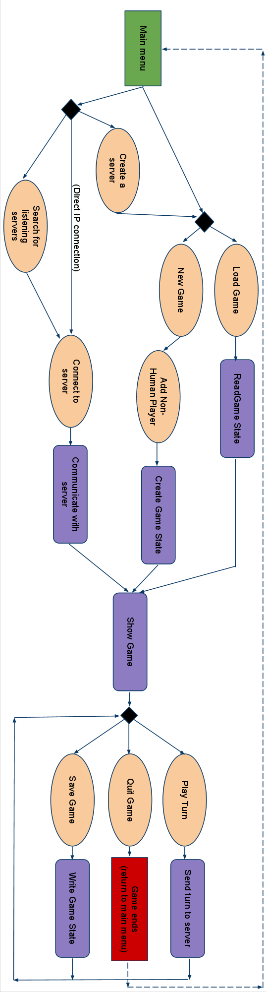
Engine interactions
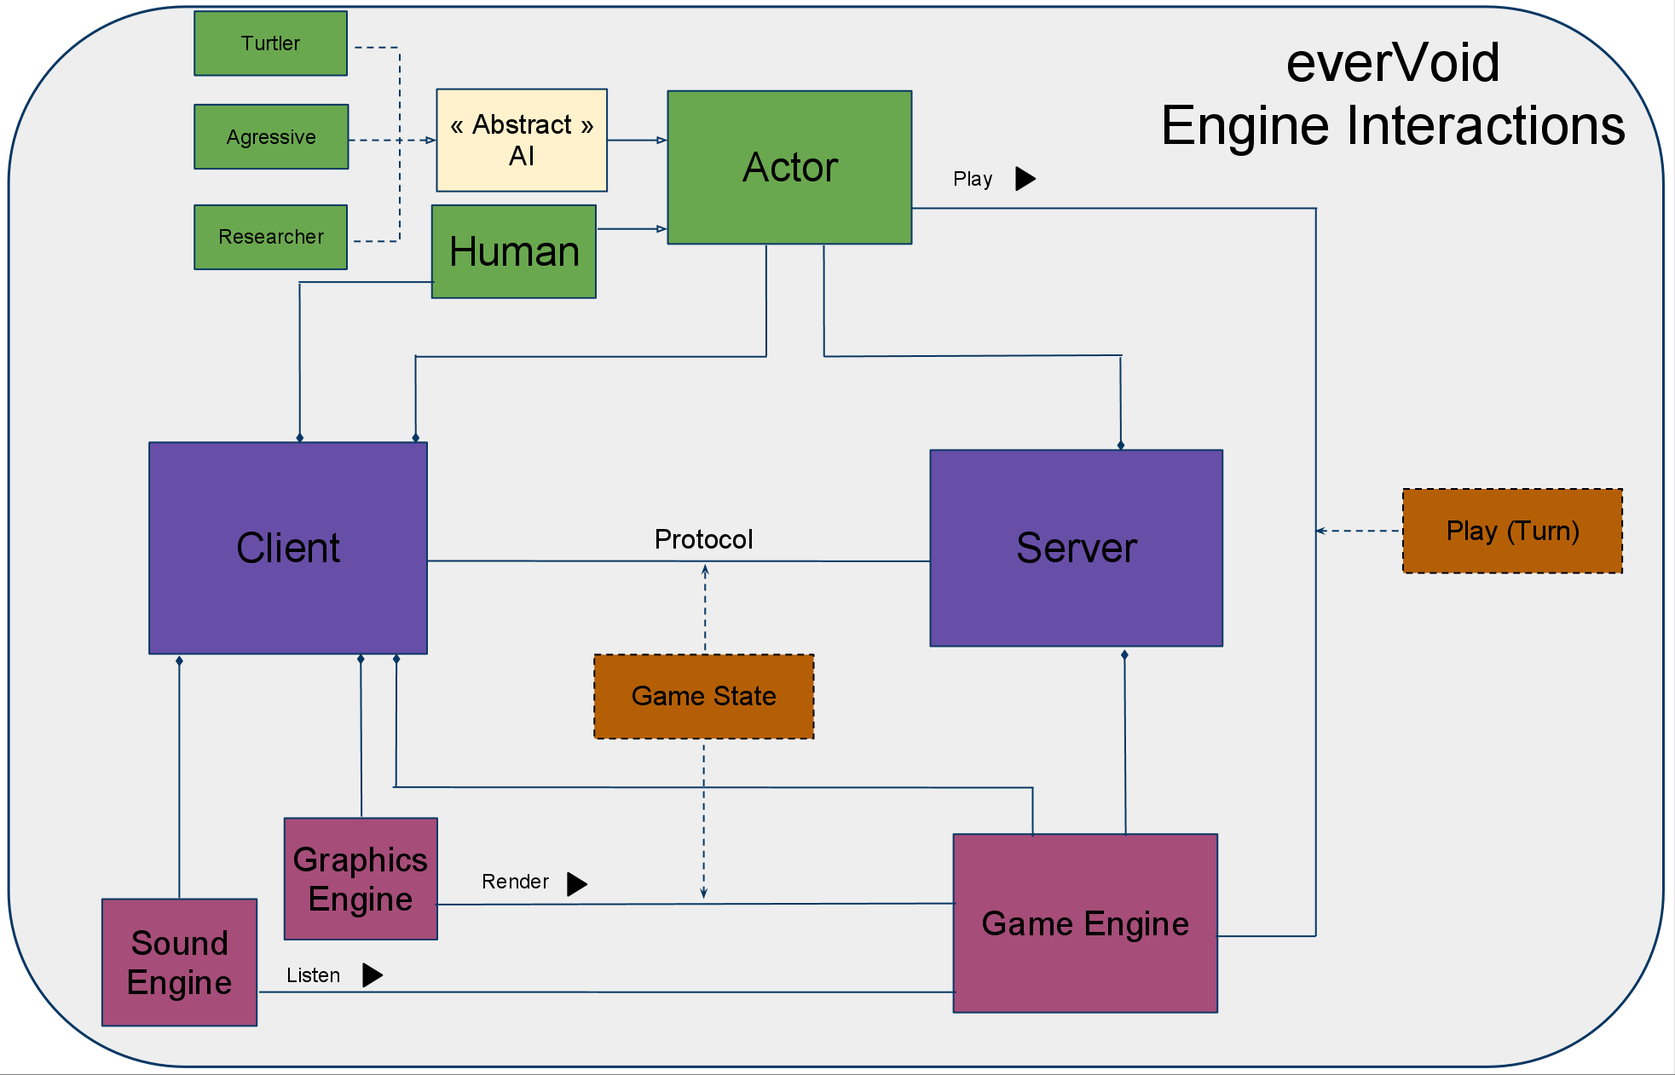

Engineering Methods

Project everVoid will be built using the Incremental development. We chose this development method for the following reasons. It makes full use of team member strengths by assigning modules to team members with prior experience in those domains. This is particularly useful due to the small size of the team, and the scope of structure challenges we will face. The development model also reduces the chance of propagating bugs from module to module by clearly delineating module borders. Therefore a module can, once tested, be used an integrated within the project with minimal effort (assuming test suits and correct implementation). Finally, the model reduces the gravity of design oversights done early in the project. Should our module design be flawed in any way (inexperience or incomplete implementation of the requirements) the model allows us to easily change the module with minimal impact on the rest of the project. Given that the entire team is new to game development, the wiggle room granted by this choice is a huge advantage of this model.

On a more personal note, this development model allows the team to acquire a deeper understanding of their specific modules. For educational and integration reasons, we would rather have well functioning modules that we understand well than a globally functional but messy implementation.

Timeline

Enlarged version available at:
http://is.gd/gymHw
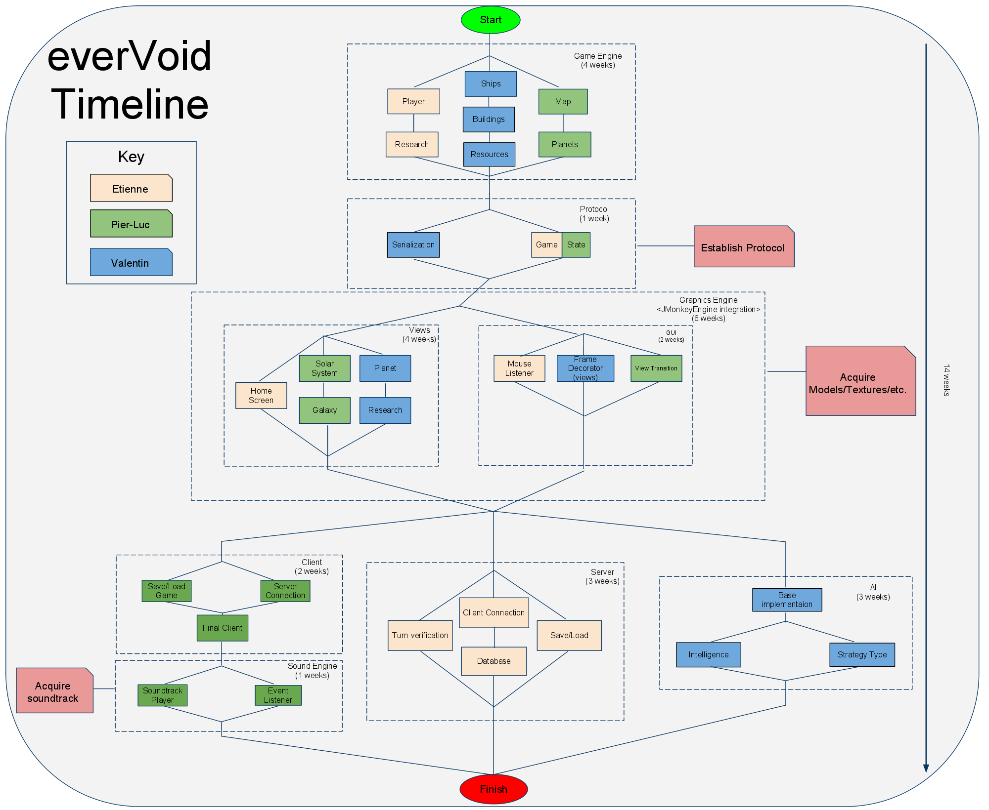

Formal Phase Breakdown

Activity | Time Estimate (days)
Milestone 1: Game Engine | 12 weeks
Step 1.1: Player  Activity 1.1.1: Game correctness  Activity 1.1.2: Associations  Activity 1.1.3: Point attribution | 6
Step 1.2: Ships  Activity 1.2.1: Movement  Activity 1.2.2: Health  Activity 1.2.3: Cost combat | 12
Step 1.3: Research  Activity 1.3.1: Research tree  Activity 1.3.2: Technology tier  Activity 1.3.3: Cost | 6
Step 1.4: Buildings | 6
Step 1.5: Resources | 3
Step 1.6: Planets | 6
Step 1.7: Map  Step 1.7.1: Default maps | 9
Milestone 2: Protocol implementation | 3 weeks
Step 2.1: Game State | 9
Step 2.2: Serialization | 3
Milestone 3: Graphics Engine | 18 weeks
Step 3.1: Graphical views  Activity 3.1.1: HUD  Activity 3.1.2: Solar system view  Activity 3.1.3: Galaxy view  Activity 3.1.4: Planet view  Activity 3.1.5: Research view | 6  12  12  9  6
Step 3.2: GUI  Activity 3.2.1: Main menu  Activity 3.2.2: Lobby/matchmaking UI  Activity 3.2.3: Client configuration menu | 6  12  6
Deliverable 1: Game with Graphics
Milestone 4: Server | 3 weeks
Step 4: Server  Step 4.1: Listening server  Step 4.2: Game state operations  Step 4.3: Game rules checking/sanitization | 2  4  6
Deliverable 2: Standalone Server
Milestone 5: Client | 3 weeks
Step 5.1: Client  Step 5.1.1: Communicate with server  Step 5.1.2: Integrate graphics engine  Step 5.1.3: Integrate sound engine | 3  6  3
Deliverable 3: Client - Server interaction
Milestone 6: AI | 3 weeks
Step 6: AI  Step 6.1: Basic AI (common behavior)  Step 6.2: AI subprofiles  Step 6.3: Adjustable hardness | 6  3  3
Deliverable 4: Fully functional Game
Total | 42 weeks
Notes:
1. Weeks are assumed to have 4 workdays
2. 42 weeks total. we have three programmers, so this is a 14 week project.

Milestone | Description | Dependency
Milestone 1: Game Engine | Implementation of the game rules, move validity, etc.
Milestone 2: Protocol implementation | Establish how the protocol will work: Client-Server communication, master server list, what information should be passed, what signals should the server respond to, etc. | M1
Milestone 3: Graphics Engine | Graphics rendering and graphical user interface implementation. | M1, M2
Milestone 4: Server | Standalone, listening, no-graphics server. | M1, M2
Milestone 5: Client | Integrate the Game Engine within the Graphics Engine; then add a Sound Engine. | M1, M2, M3
Milestone 6: AI | Implement intelligent non-human players able to interact with the game engine and the server using the defined protocol. | M1, M2

Deliverable | Description | Dependency
Deliverable 1: Game with Graphics | A working game client with a graphics engine and a sound engine | M1, M2, M3
Deliverable 2: Standalone Server | A standalone listening server to which clients can connect | M1, M2, M4
Deliverable 3: Client - Server interaction | A full client+server package, with the client being able to run a server on the same machine as itself | M1, M2, M4, M5
Deliverable 4: Fully functional Game | Fully functional game, still needs testing for gameplay. | M1, M2, M3, M4, M4, M6

(This is a simplified Gantt chart, complete chart available at http://evervoid.biringa.com/images/gantt.png)
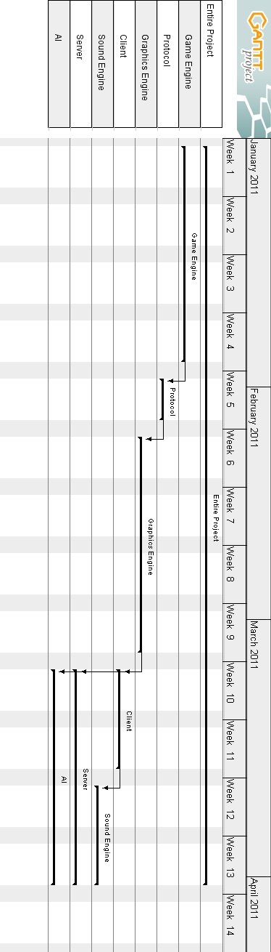

Project Modules

- Game Engine
  - Resource management
  - Research management
  - Unit management
  - Building management
- Graphics Engine
  - Main menu
    - Lobby interface
    - Matchmaking interface
    - Save/Load dialogs
  - Galaxy View
    - Solar Systems, Wormholes
  - Solar System View
    - Props (Ships, Planets, pretty art things, ...)
  - Planet view
    - Buildings
    - Current Action Progress
  - Research view
    - Progress
    - Research Tree
  - Models/sprites/art
    - Logo, UI elements
    - Ship, Building, Planet, Star sprites and models
- Protocol
  - Client (Uploading saved games to server, auto-reconnect)
  - Server (Resuming saved games, ping clients and notify players of drops
  - Master server
    - Server list database (Purge list regularly)
  - Game state synchronization:
    - State diff (sending only differences)
    - State hash (confirmation)
    - State resolver (movement conflicts)
- Sounds
  - Soundtrack
  - Sound effects (Explosions, lasers, etc)
  - Game milestones announcements (research finished, tier reached, planet destroyed, game won...)
- Artificial Intelligence
  - Type
  - Difficulty

Resource Requirements
- Graphics:
  - Logo, icon, splash screen
  - Ship sprites, buildings sprites, planets sprites
  - 3D planet models
  - Wormhole effects
  - UI design
  - Icons for buttons, research, etc
- Audio:
  - Soundtrack (main menu music, in-game background music)
  - Ship sound effects (firing, explosion, dropping, building, moving)
  - Planet sound effects (construction, explosion, resource gathering)
  - Announcer (game events, research complete, player dead)
  - UI sounds (button click, game paused, new message blip)
- Server:
  - Always-on master server (holds list of online servers)
    - Requires Apache and MySQL
  - “Official” dedicated servers
- Skills:
  - jMonkeyEngine expertise/learning curve
  - Knowledge of SQL
  - Knowledge of Java

Cost estimate

- We will be using Java with jMonkeyEngine and MySQL, all of which are free
- Audio/graphics royalties if necessary
- Estimated cost range: $0 - $100

Risk Estimation

Risk | Component | Severity | Fix Time
Time estimates are off / Workload too big - cannot finish project | Whole project | Critical | N/A
Learning curve is too important for external packages (jMonkeyEngine) | Game client | Major (if requires an engine change) | 3 weeks
Server takes too long to process turns | Server | Major | 1 week
Game play is unbalanced (too hard or too easy) / Game is not fun | Gameplay | Major | 1 week
Game is too similar to other games; no competitive advantage | Gameplay | Minor | N/A
Cannot find free soundtrack / graphics | Audio | Minor | Do not fix
Unappealing Graphics/sprites | Graphics | Minor | Increases costs, hire an artist

The end

